**Output:**

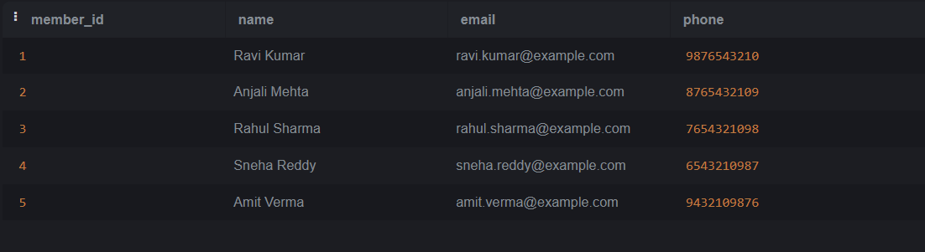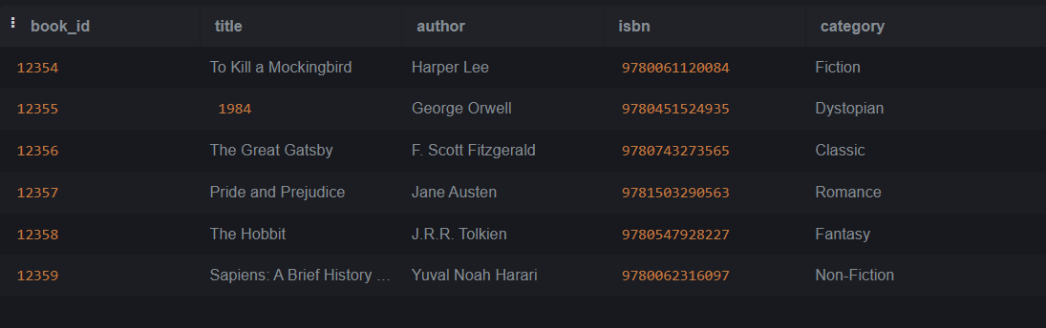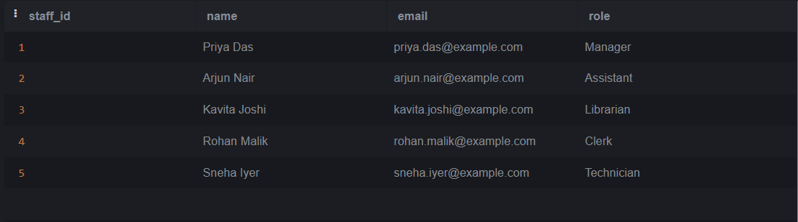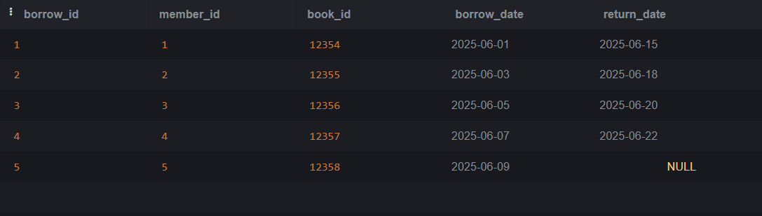

**ER DIAGRAM:**

Members Books

--------- ----------

member_id <──┐ book_id <──┐

name │ title │

email │ author │

phone │ category │

│ │

▼ ▼

Borrowings (join table)

-------------------------

borrow_id (PK)

member_id (FK to Members)

book_id (FK to Books)

borrow_date

return_date